Page | Corrections | Expected Output
Home Page | 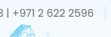 | Change the No to  +971 544772700
Home Page | 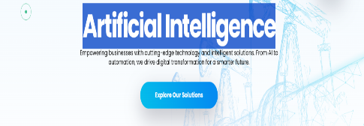 | Add solutions like  - Digital & AI-Powered Engineering  - AI-Powered Maintenance & Asset Intelligence  - Business Process Improvement
Home Page | 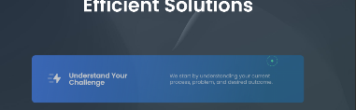 | Add Heading for this as What You Can Expect from Arti Bits
Home Page | Replace the video | Add the video that was in the folder(Quality Improved)
About us | 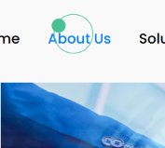 | Add filters  - WHO WE ARE  - WHAT WE DO  - WHY ARTI BITS?  - WHO WE SERVE  - DATA SECURITY & RESPONSIBLE AI
About us | 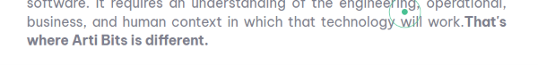 | Make the wordings as separate caption “That's where Arti Bits is different.”
About us | 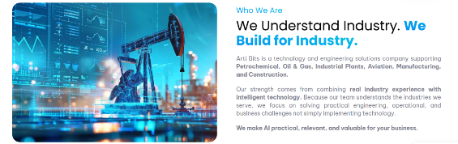 | Under this highlight and add as “Arti Bits Technical Services is officially certified under the UAE In-Country Value (ICV) Program, demonstrating our commitment to local value creation and industrial capability”and ICV image
Solution Page | 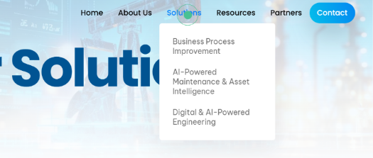 | Add Filters as  - Digital & AI-Powered Engineering  - AI-Powered Maintenance & Asset Intelligence  - Business Process Improvement
Solution Page |  | Under Digital & AI-Powered Engineering add filters of all its solutions like AI-Driven P&ID & Isometric Digitization, Engineering Compliance Verification etc... Also, for AI-Powered Maintenance & Asset Intelligence & Business Process Improvement
Solution Page | 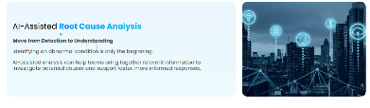 | Remove this from AI-Powered Maintenance & Asset Intelligence solutions
Solution Page | 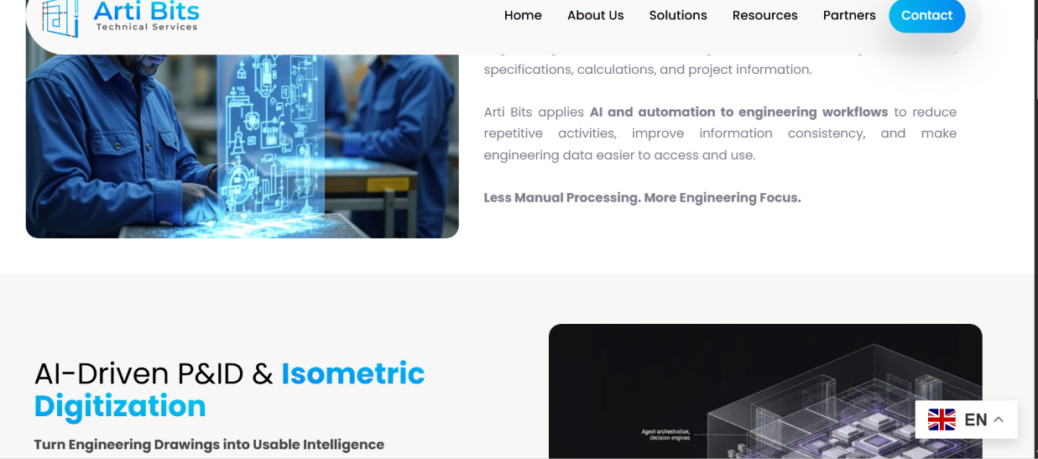 | 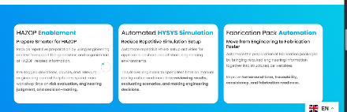  Align all the solutions in zig zag manner for all  Don’t want like this in the middle
Resource Page |  | High light like how solutions are highlighted and font size can be increased
Resource Page | Drishya Case Studies | Drishya Case studies doc attached in the folder add that content also
Resource Page | 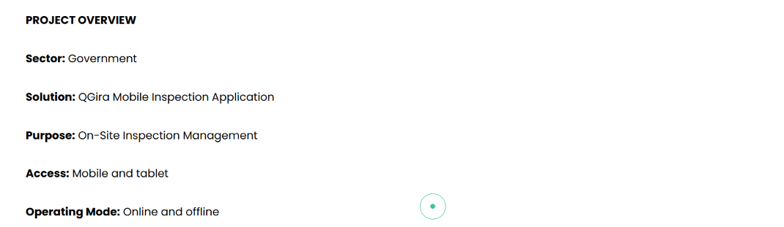 | This section can be aligned horizontally and highlighted for all case studies
Resource Page | 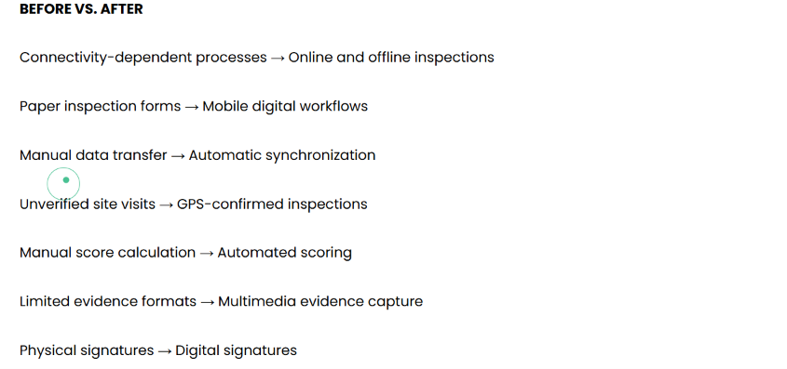 | This Before and After section can be highlighted as comparison table for all the case Studies
Resource Page | 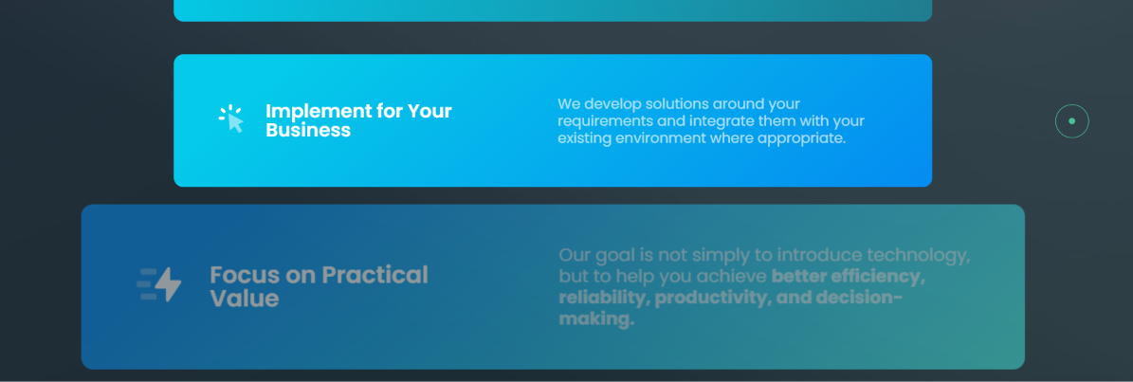 | Like this Home page layout, you can align this section horizontally & highlight to match the Resource page content, keeping it light and without heavy text
Resource Page | 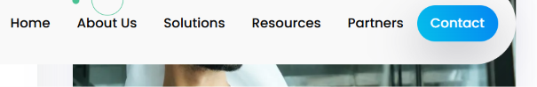 | Here add filters for resources as like solution  - All  - Oil & Gas  - EPC  - Manufacturing  - Construction  - Government
Resource Page | 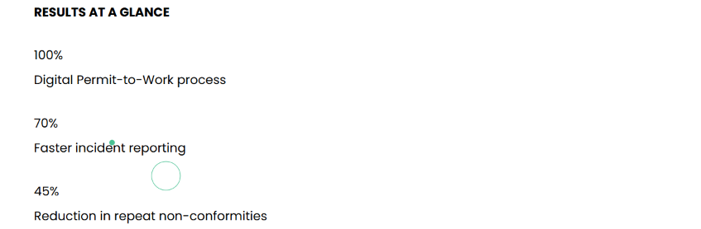 | Results at Glance section can be aligned horizontally and highlighted
Partners Page | 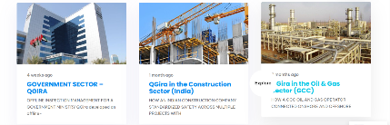 | Partner section has to be aligned like the case studies

Correction -2

About Page | 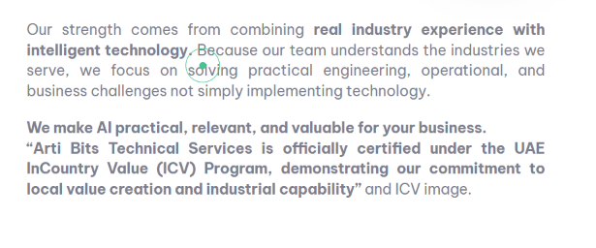 | Remove Wordings and ICV IMAGE  Do add ICV Image
Partners Page |  | Align 3 tiles in a row so that there won’t be gap to the right can reduce the size of the tile
Resource Page | 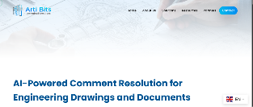 | Don’t want gap at the top for all the case studies
Home Page | 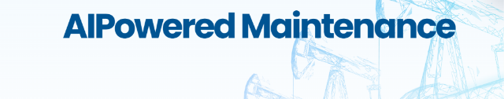 | Change to AI-Powered Maintenance and for Digital & AI-Engineering solutions
Resource Page | 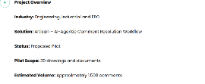 | Arrange and visualize in better way for all
Resource Page |  | 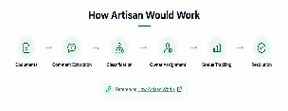Something like this for how it works for all
Resource Page | 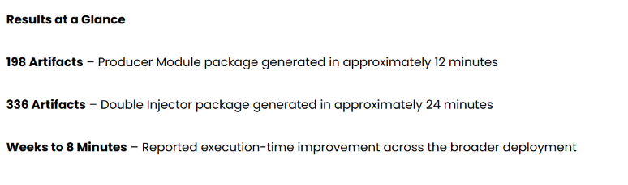 | 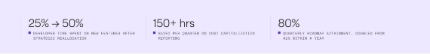  something like this for result at glance for all
Home Page | 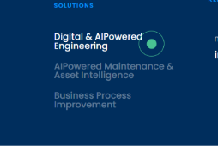 | Wordings change - Change to Digital & AI-Engineering solutions and for AI-Powered Maintenance
Resource Page | 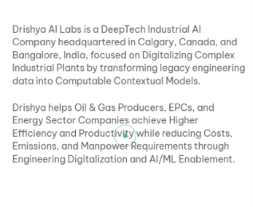 | Align to Justify
Home Page | 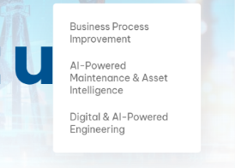 | Change to this alignment  - Digital & AI-Powered Engineering (at top)  - AI-Powered Maintenance & Asset Intelligence (middle)  - Business Process Improvement (Bottom)
Home Page | Change the VIDEO that is available in the folder

